ILLINOIS POLLUTION CONTROL BOARD
February 17, 2005

IN THE MATTER OF:  PROPOSED AMENDMENTS TO:  REGULATION OF PETROLEUM LEAKING UNDERGROUND STORAGE TANKS (35 ILL. ADM. CODE 732  ______________________________________ | )  )  )  )  )  ) | R04-22  (UST Rulemaking)
IN THE MATTER OF:  PROPOSED AMENDMENTS TO:  REGULATION OF PETROLEUM LEAKING UNDERGROUND STORAGE TANKS (35 ILL. ADM. CODE 734 | )  )  )  )  )  ) | R04-23  (UST Rulemaking)  Consolidated

CONCURRING OPINION (by T.E. Johnson):

I respectfully concur with the majority opinion. I agree with the majority that the proposal is technically feasible and economically reasonable, and further agree that proceeding to first notice with the proposal is proper. However, I remain undecided on the specific issue of excluding handling charges for subcontractors where the primary contractor has a financial interest in the subcontractor.

The majority finds that the record to date does not indicate that a primary contractor or consultant who has a financial interest in a business which subcontracts part of the work associated with remediation of a site incurs the same costs as a primary contractor without the financial interest. Accordingly, the majority proposes for first notice the Illinois Environmental Protection Agency’s language, which excludes handling charges for subcontractors where the primary contractor has a financial interest in the subcontractor. While the majority does invite comment on this issue, I wish to take this opportunity to underscore my concerns. It is my hope that this issue will be further briefed during the first-notice period, and that, with additional information in hand; the Board will be fully able to reconsider its position prior to deciding whether or not to adopt the rule for second notice.

For these reasons, I respectfully concur.


Thomas E. Johnson
Board Member

I, Dorothy M. Gunn, Clerk of the Illinois Pollution Control Board, certify that the above concurring opinion was submitted on February 17, 2005.
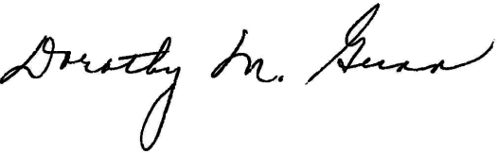
Dorothy M. Gunn, Clerk
Illinois Pollution Control Board

